NYSSLS Daily Lesson Plan
Instructional Unit: Geologic History – Scientific reasoning and evidence of Earth’s formation and early history |  |  |  |  | Period(s) of Unit: |  |  | Date:
Materials/Resources/Links:  2024 Edition – Earth and Space Science Reference Tables  earth_space_science_ref_tables_2024.pdf (nysed.gov)  Resources for Evidence:  Images of Ancient Earth Materials (Rocks, Minerals)  Smithsonian National Museum of Natural History:  Website: Smithsonian National Museum of Natural History  Rock and Mineral Gallery: Smithsonian Rock and Mineral Gallery  United States Geological Survey (USGS):  Website: USGS  USGS Mineral Resources Program: USGS Minerals  Image Library: USGS Science Images  Images of Meteorites  NASA Astromaterials Research & Exploration Science (ARES):  Website: NASA ARES  Meteorite Collection: NASA Meteorite Collection  The Natural History Museum, London:  Website: Natural History Museum  Meteorites Collection: Meteorites at NHM  The Meteoritical Society:  Website: The Meteoritical Society  Image Database: The Meteoritical Society Image Database  Images of Planetary Surfaces  NASA Solar System Exploration:  Website: NASA Solar System Exploration  Mars Exploration Program: NASA Mars  Moon Exploration: NASA Moon  European Space Agency (ESA):  Website: ESA  Planetary Science Archive: ESA PSA  USGS Astrogeology Science Center:  Website: USGS Astrogeology Science Center  Planetary Maps and Images: USGS Planetary Maps  Sample Images and Resources:  - Smithsonian Rock and Mineral Gallery:  - Example Image: Quartz  - Source: Smithsonian National Museum of Natural History  - NASA Meteorite Collection:  - Example Image: Meteorite  - Source: NASA ARES  - NASA Mars Exploration:  - Example Image: Mars Surface  - Source: NASA Mars Exploration Program |  |  |  |  |  |  |  | Course: Earth and Space Science
Special Notes for Lesson:
- Interdisciplinary Connections
  - Chemistry: Understanding of atomic structure, isotopes, and radioactive decay processes
  - Physics: Basic principles of nuclear reactions and radiometric dating techniques
  - History of Science: Overview of key scientific discoveries related to Earth's formation and the development of geological theories
- Scientific Skills Emphasis
  - Critical Thinking: Encouraging students to analyze and evaluate different sources of evidence
  - Scientific Reasoning: Applying logical reasoning to connect evidence with theories about Earth's history
  - Data Interpretation: Skills in interpreting radiometric data and understanding geological timelines

Prior Knowledge to Review
- Basic Geological Concepts
  - Rock Types: Familiarity with igneous, sedimentary, and metamorphic rocks
  - Geological Time Scale: Basic understanding of Earth's major geological eras and periods (2024 ESRT pages 6 and 7)
- Fundamentals of Radiometric Dating
  - Radioactive Decay: Concepts of half-life and how isotopes are used to date materials
  - Dating Techniques: Introduction to common radiometric dating methods such as carbon-14 dating, uranium-lead dating, and potassium-argon dating
- Solar System Formation
  - Nebular Hypothesis: Basic theory of how the solar system formed from a nebular cloud of gas and dust
  - Planetary Differentiation: Understanding how planets formed and differentiated into core, mantle, and crust
- History of Earth Science:
  - Key Figures: Overview of contributions from scientists like James Hutton, Charles Lyell, and Marie Curie
  - Major Discoveries: Key historical discoveries that shaped our understanding of Earth's formation and history
Anchoring Phenomenon: https://www.youtube.com/watch?v=hOKbs-xKD5Q
Ann Hodges has the distinction of being the only human to have been hit by a meteorite. While Mrs. Hodges was napping on the couch the meteorite impacted her house, bounced off a table and hit her in the hip. She was able to walk away from the incident. Scientists can learn about the composition of the early solar system and the formation of the Earth by studying these primordial objects orbiting in space.
- How common are meteorite impacts on Earth, and what factors influence the likelihood of such events?
- What kind of information can meteorites provide about the early solar system?
- How do meteorite impact events influence Earth's environment and ecosystems? Can you think of any historical examples?
Standards: HS-ESS1-6. Apply scientific reasoning and evidence from ancient Earth materials, meteorites, and other planetary surfaces to construct an account of Earth’s formation and early history.
Science and Engineering Practices  Constructing Explanations and Designing Solutions  - Apply scientific reasoning to link evidence to the claims to assess the extent to which the reasoning and data support the explanation or conclusion.  Connections to Nature of Science  Science Models, Laws, Mechanisms, and Theories Explain Natural Phenomena  - A scientific theory is a substantiated explanation of some aspect of the natural world, based on a body of facts that have been repeatedly confirmed through observation and experiment and the science community validates each theory before it is accepted. If new evidence is discovered that the theory does not accommodate, the theory is generally modified in light of this new evidence.  - Models, mechanisms, and explanations collectively serve as tools in the development of a scientific theory. |  | Disciplinary Core Idea(s)  ESS1.C: The History of Planet Earth  - Although active geologic processes, such as plate tectonics and erosion, have destroyed or altered most of the very early rock record on Earth, other objects in the solar system, such as lunar rocks, asteroids, and meteorites, have changed little over billions of years. Studying these objects can provide information about Earth’s formation and early history.  PS1.C: Nuclear Processes  - (NYSED) Spontaneous radioactive decay follows a characteristic exponential decay law allowing an element’s half-life to be used for radiometric dating of rocks and other materials. |  |  |  |  | Cross Cutting Concepts  Stability & Change  - Much of science deals with constructing explanations of how things change and how they remain stable.
Performance Level
NYS Level 5 | NYS Level 4 |  | NYS Level 3 |  |  | NYS Level 2 |  |  | NYS Level 1
Analyze empirical evidence from multiple sources, to construct an explanation of Earth’s formation and early history, based upon the assumption that theories and laws that describe the natural world operate today as they did in the past and will continue to do so in the future. | Apply scientific reasoning and evidence from ancient Earth materials, meteorites, and other planetary surfaces to construct an account of Earth’s formation and early history. |  | Using evidence and scientific reasoning from ancient Earth materials, or meteorites, or other planetary surfaces, construct an account of Earth’s formation and/or early history, or use evidence from radiometric dating of rocks and/or other materials to construct an account of the formation or early history of objects in the solar system. |  |  | Describe or identify the evidence from ancient Earth materials, or meteorites, or other planetary surfaces (other objects in the solar system) to support/refute a given explanation of Earth’s formation and/or early history or use evidence from radiometric dating to support/refute a given explanation of the formation of a solar system object. |  |  | Identify the evidence (radiometric dating, impact cratering), from those provided, that supports/refutes a given explanation of Earth’s or another planetary surface formation or early history.
Clarification Statement  Emphasis is on using available evidence within the solar system to reconstruct the early history of Earth, which formed along with the rest of the solar system 4.6 billion years ago. Examples of evidence include the absolute ages of ancient materials (obtained by radiometric dating of meteorites, moon rocks, and Earth’s rocks and minerals), the sizes and compositions of solar system objects, and the impact cratering record of planetary surfaces. |  |  |  | Assessment Boundary
Connection to Anchoring Phenomenon:
What are meteorites, and how do they differ from meteors and asteroids?
Connection: Use Ann Hodges' meteorite as a concrete example to explain the differences and classify the space object that struck her.
How common are meteorite impacts on Earth, and what factors influence the likelihood of such events?
Connection: Discuss how rare it is for meteorites to hit humans, connecting this to the probability and factors influencing meteorite impacts. Explore how the study of these events helps predict and understand their occurrence.
What scientific processes can we use to determine the origin and age of meteorites?
Connection: Explain how scientists would analyze the meteorite that hit Ann Hodges, linking it to techniques like radiometric dating and isotopic analysis.
What kind of information can meteorites provide about the early solar system?
Connection: Use the meteorite to discuss how such objects are studied to gain insights into the early solar system’s conditions and materials.
Essential Question(s):
- What types of evidence from ancient Earth materials, meteorites, and planetary surfaces contribute to our understanding of Earth's formation and early history?
  - How do geologists use rock samples to trace the history of Earth's formation?
  - What role do meteorites play in providing information about the early solar system?
- How does scientific reasoning and evidence from radiometric dating help construct an account of Earth's formation and early history?
  - What is radiometric dating, and how is it used to determine the age of Earth materials?
  - How do radiometric dating techniques support or challenge existing theories about Earth's early history?
- In what ways do ancient Earth materials, meteorites, and other planetary surfaces provide evidence for or against current explanations of Earth's formation?
  - What specific characteristics of meteorites can be analyzed to infer the conditions of the early solar system?
  - How do impact craters on Earth and other planets inform our understanding of planetary formation and history?
- How can the evidence from ancient Earth materials or meteorites be used to support or refute a given explanation of Earth's early history?
  - What are some major hypotheses about Earth's formation, and what evidence supports or contradicts them?
  - How do scientists use data from planetary surfaces to compare the histories of Earth and other planets?
- What methods and evidence do scientists use to construct accounts of the formation and early history of objects in the solar system?
  - How do scientists use evidence from lunar rocks to understand the Moon's formation and history?
  - What can the study of other planetary surfaces, such as Mars, tell us about the formation and evolution of the solar system?
- How do impact cratering and other geological processes provide insights into the formation and history of planetary surfaces?
  - What information can be derived from studying the distribution and characteristics of impact craters on Earth and other planets?
  - How do geological processes observed on Earth help in interpreting the history of other planetary bodies?
- How does the analysis of ancient Earth materials contribute to our understanding of significant events in Earth's early history, such as the formation of the crust or the appearance of water?
  - What evidence suggests when and how Earth's crust formed?
  - How do scientists determine the timeline for the appearance of water on Earth's surface?
Instructional Strategies & Learning Tasks: Engage, Explore, Explain, Elaborate, Evaluate
Engage: Anchoring phenomenon, demonstration; observations of images, video clip or data… |  | Objective: Spark students' interest and curiosity about the topic.  Activity: Show an engaging video clip about the formation of Earth and the solar system.  Video Resource: https://www.khanacademy.org/humanities/big-history-project/solar-system-and-earth/earth-and-form-solar-system/v/bhp-how-did-earth-solar-system-form  Discussion Questions:  - What did you find most surprising about the formation of Earth?  - Why is it important to study meteorites and other planetary surfaces to understand Earth's early history?  - How do scientists determine the age of Earth materials and meteorites?
Explore: Students investigate, experiment, hands-on activity…. |  | Objective: Allow students to investigate and gather information.  Activity: Divide students into small groups and provide them with samples or images of ancient Earth materials (e.g., rocks, minerals), meteorites, and images of other planetary surfaces.  Instructions: Each group will rotate through stations with different types of evidence. At each station, students will observe, make notes, and answer guiding questions about the age, composition, and significance of the samples.  Guiding Questions:  - What does the composition of these materials tell us about early Earth?  - How do meteorites provide clues about the early solar system?
Explain: Students share their observations and evidence to explain their understanding…possible whole group/class discussion… |  | Objective: Facilitate understanding through teacher-led instruction.  Activity: Teacher lecture to explain the scientific reasoning and methods used to analyze evidence from ancient Earth materials, meteorites, and planetary surfaces.  Topics to be highlighted:  - Radiometric dating techniques  - Comparison of Earth's materials with meteorites  - The role of planetary surfaces in understanding the early solar system
Elaborate: Students apply the science concepts they’ve just learned… |  | Objective: Extend students' understanding and apply it to new situations.  Activity: Have students work in their groups to construct a timeline of Earth's formation and early history based on the evidence they examined. They should include:  - The formation of the solar system  - The differentiation of Earth  - Major events in early Earth history (e.g., formation of the moon, late heavy bombardment)  Presentation: Each group will create a visual presentation (poster, digital slideshow) of their timeline and present it to the class.
Evaluate (Formative Assessment): Student learning is evaluated. |  | Objective: Assess students' understanding and provide feedback.  Assessment:  - Formative: Observe group discussions and provide feedback during the Explore and Elaborate phases  - Summative: Evaluate students' timelines and presentations based on accuracy, completeness, and clarity  - Quiz: Administer a short quiz with questions about the key concepts covered (e.g., "What is radiometric dating?", "How do meteorites help us understand Earth's history?")

See attached for:
- Notes Overview
- Worksheet – Important Radioactive Elements Used for Radiometric Dating
- Worksheet – Geologic History of New York State
- Quiz – Formation and Early History of Earth and the Solar System
- Cluster – Formation and Early History of Earth and the Solar System

Name: Geologic History
Date: Period: Earth and Space Science
Notes Overview – HS-ESS1-6
Explore how scientists use evidence from ancient Earth materials, meteorites, and planetary surfaces to construct an account of Earth’s formation and early history.

CORE OBJECTIVES:
- Understand Radiometric Dating Techniques: Learn how scientists determine the age of rocks and meteorites.
- Compare Earth's Materials with Meteorites: Analyze the similarities and differences to understand their origins.
- Analyze Planetary Surfaces: Study how the features of planetary surfaces help us reconstruct the early solar system.

VOCABULARY:

- meteorites
- planetary surfaces
- solar system
- absolute age
- radiometric dating
- moon rocks
- impact cratering
- erosion
- lunar rocks
- asteroids
- radioactive decay
- exponential decay law
- half-life

Notes Overview – HS-ESS1-6
Radiometric Dating Techniques
OVERVIEW:
Radiometric dating is a technique used to date materials such as rocks or carbon, based on the known decay rates of radioactive isotopes. This method provides absolute ages of materials, which is crucial in understanding the timeline of Earth's formation.
KEY CONCEPTS:
- Isotopes and Decay: Atoms of the same element with different numbers of neutrons. Over time, these isotopes decay at a predictable rate.
- Half-Life: The time required for half of the isotope in a sample to decay. This is a constant value for each radioactive isotope.
TECHNIQUES:
- Uranium-Lead Dating: Often used for dating zircon crystals in igneous rocks.
- Potassium-Argon Dating: Used for dating volcanic rocks.
- Carbon-14 Dating: Useful for dating relatively recent organic remains.
ACTIVITY:
- Graphing Decay Rates: Students will plot the decay curves of different isotopes and use these to determine the age of sample rocks.

Name: Geologic History
Date: Period: Earth and Space Science
Activity – Graphing Decay Rates
Directions: Use the following stimuli highlighting scientific reasoning and evidence from ancient Earth materials, meteorites, and other planetary surfaces to answer the questions that follow to construct an account of Earth’s formation and early history.

STIMULI:
Reading Passage 1 – Ancient Earth Materials
Ancient Earth materials, such as zircon crystals, are some of the oldest materials found on Earth. Zircons can be dated back to over 4 billion years ago and provide a record of the conditions on early Earth. These crystals contain uranium, which decays to lead at a known rate, allowing scientists to determine their age.

Reading Passage 2 – Meteorites
Meteorites are remnants of the early solar system that have not undergone significant changes since their formation. By studying meteorites, scientists can gather information about the composition and conditions of the early solar system. For example, chondrites contain small, round particles called chondrules, which are among the oldest solid materials within the solar system.

Data Table 1 – Decay of Carbon-14
Time (years) | % C-14 Remaining
0 | 100%
5,730 | 50%
11,460 | 25%
17,190 | 12.5%

Graph 1 – Decay Curve of Uranium-238
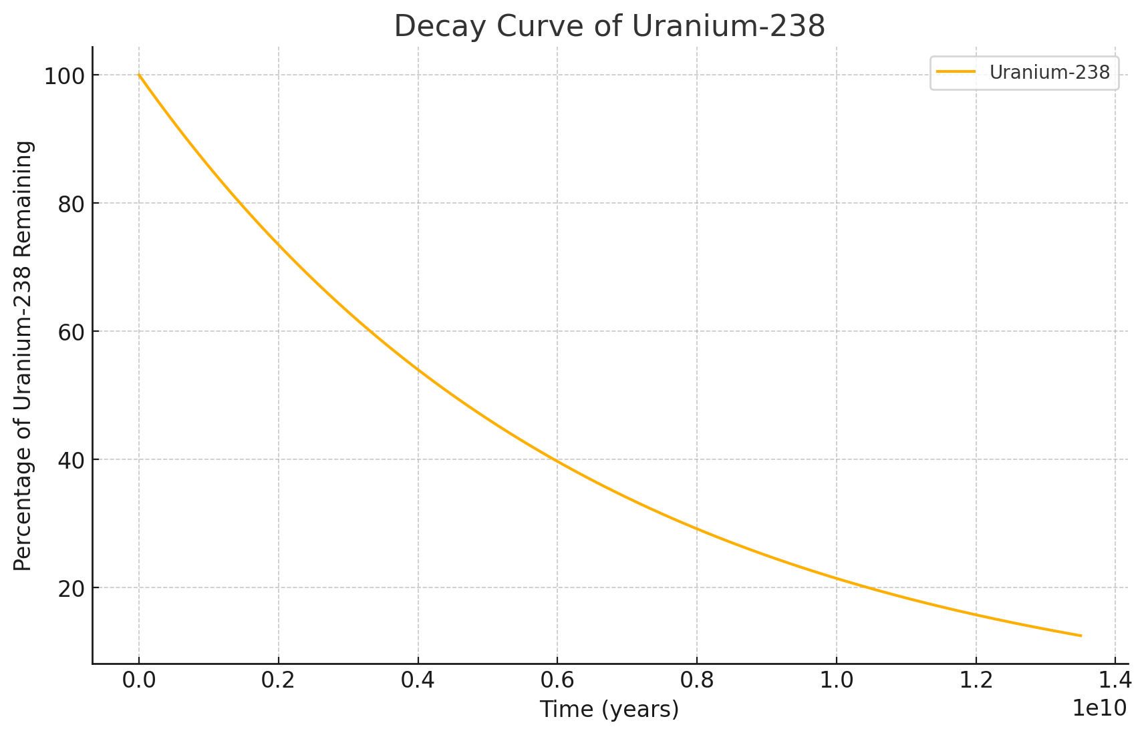
Activity – Graphing Decay Rates
Diagram 1 – Impact Craters on Earth
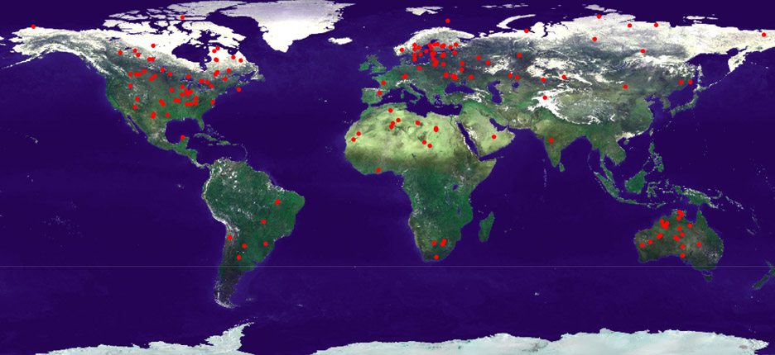

Photo 1 – Surface of Mars
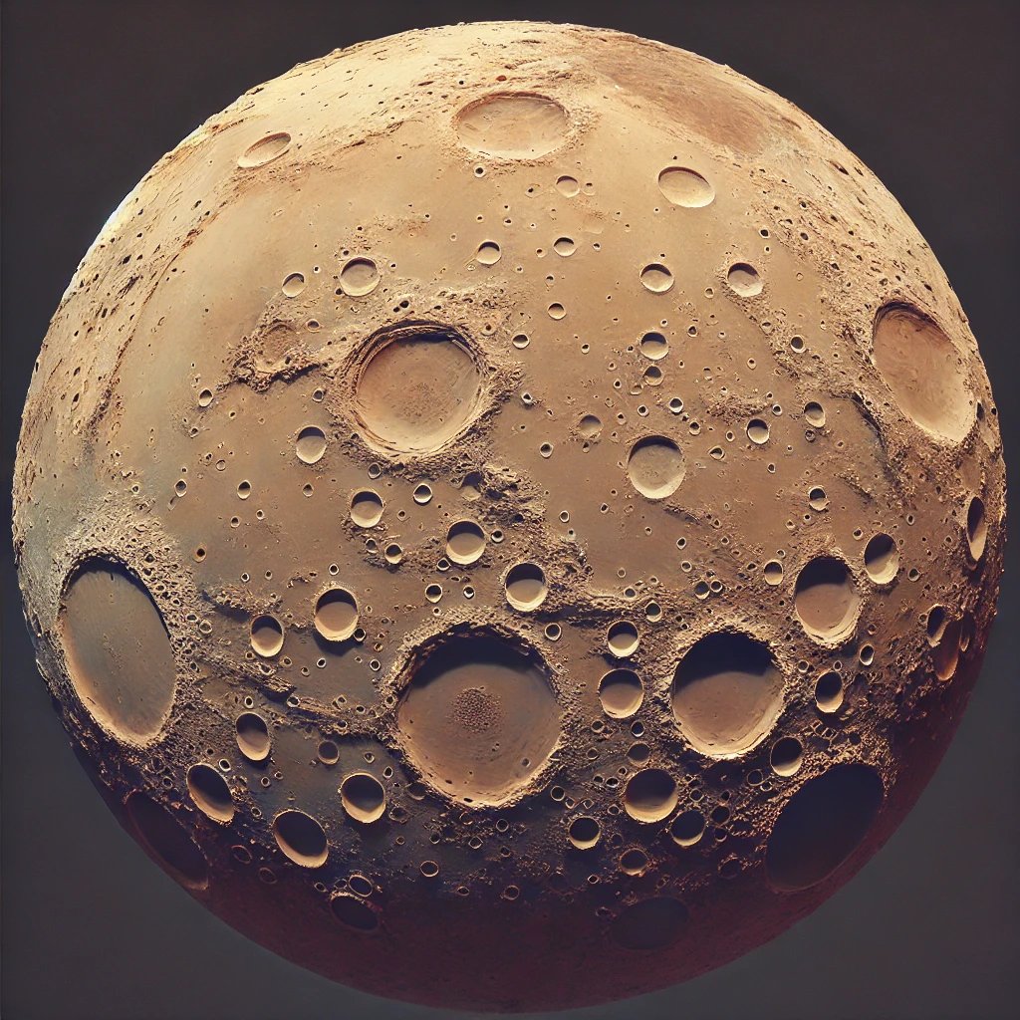

Activity – Graphing Decay Rates
QUESTIONS:
- Scientific Reasoning & Evidence – Using Reading Passage 1, explain how zircon crystals provide evidence for the formation and early history of Earth. Include specific examples from the passage.

- Meteorites Evidence – Based on Reading Passage 2, describe how the study of chondrites helps scientists understand the conditions of the early solar system.

- Radiometric Dating – Using Data Table 1, plot the decay curve for Carbon-14. Determine the percentage of Carbon-14 remaining after 5,730 years, 11,460 years, and 17,190 years. Provide your plot and calculations.
Decay of Carbon-14

Percentage of C-14 remaining

Time (years)

C-14 remaining after 5,730 years: %
C-14 remaining after 11,460 years: %
C-14 remaining after 17,190 years: %
Activity – Graphing Decay Rates
- Determining Rock Age – Using Graph 1, determine the age of a rock sample that has 25% of its original Uranium-238 remaining. Show your work and explain your reasoning.
Age of rock sample: years
Explanation:

- Supporting/Refuting Explanations – Refer to Diagram 1 and describe how the evidence of impact cratering on Earth's surface supports or refutes the explanation of a heavy bombardment period in Earth’s early history.

- Comparison of Planetary Evidence – Compare the evidence from Earth's ancient rocks, as described in Reading Passage 1, with evidence from the Moon's surface (not provided here). Discuss how similarities and differences in this evidence help us understand the early history of the Earth-Moon system.

Activity – Graphing Decay Rates

KEY – Example responses include:

- Zircon crystals provide evidence for the formation and early history of Earth as they can be dated back to over 4 billion years ago. These crystals contain uranium, which decays to lead at a known rate, allowing scientists to determine their age. The presence of zircon crystals indicates that solid crust formed on Earth early in its history, providing a record of the conditions at that time.
- Chondrites contain small, round particles called chondrules, which are among the oldest solid materials within the solar system. By studying chondrites, scientists can gather information about the composition and conditions of the early solar system. The elements and isotopes found in chondrites provide clues about the processes that occurred during the formation of the solar system, such as the cooling and solidification of the solar nebula.
- After 5,730 years (one half-life), 50% of Carbon-14 remains.
After 11,460 years (two half-lives), 25% of Carbon-14 remains.
After 17,190 years (three half-lives), 12.5% of Carbon-14 remains.
The plot should show an exponential decay curve, starting at 100% and decreasing to 50%, 25%, and 12.5% at the respective time points.
- From Graph 1, we see that 25% of Uranium-238 remains after 9 billion years (two half-lives of 4.5 billion years each). Therefore, the age of the rock sample is approximately 9 billion years.
- Diagram 1 shows significant impact craters on Earth's surface, with various ages indicating a period of heavy bombardment. The distribution and frequency of these craters support the explanation of a heavy bombardment period in Earth’s early history, as it suggests a time when Earth experienced frequent and large impacts from celestial bodies.
- Photo 1 shows the heavily cratered surface of Mars, indicating a history of impacts similar to that of early Earth. By studying the impact craters on Mars, scientists can infer the frequency and scale of impacts that may have also affected Earth. One specific finding is the overlapping craters, which suggest multiple impact events over time, providing a timeline for understanding the early bombardment history of both planets.

Name: Geologic History
Date: Period: Earth and Space Science
Notes Overview – HS-ESS1-6
Explore how scientists use evidence from ancient Earth materials, meteorites, and planetary surfaces to construct an account of Earth’s formation and early history.

Core Objectives:
- Understand Radiometric Dating Techniques: Learn how scientists determine the age of rocks and meteorites.
- Compare Earth's Materials with Meteorites: Analyze the similarities and differences to understand their origins.
- Analyze Planetary Surfaces: Study how the features of planetary surfaces help us reconstruct the early solar system.

Comparison of Earth's Materials with Meteorites

OVERVIEW:
Meteorites are remnants of the early solar system and can provide valuable information about its composition and formation processes.

KEY POINTS:
- Chondrites: A type of stony meteorite that has not undergone melting or differentiation, representing the building blocks of the solar system.
- Iron Meteorites: Believed to originate from the core of differentiated planetesimals.
- Achondrites: Stony meteorites that have undergone differentiation, similar to terrestrial igneous rocks.

COMPARISON ACTIVITY:
- Hands-on Examination: Students will examine samples (or images) of Earth rocks and various types of meteorites, identifying key similarities and differences.
- Data Tables: Compare the chemical compositions and isotopic ratios of Earth rocks and meteorites.

Notes Overview – HS-ESS1-6
Use handheld samples for granite and basalt (images are provided if no physical samples are available)

Granite
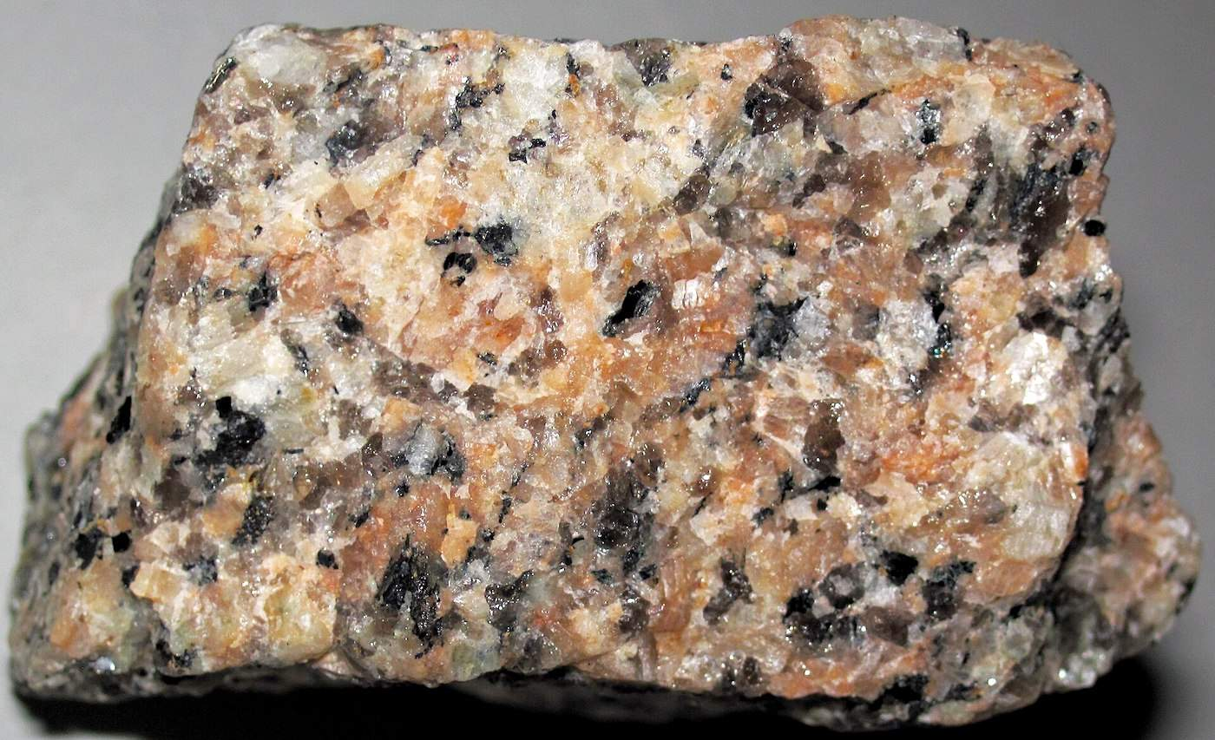

Igneous Rock Pahoehoe Basalt from Hawaii at the National Museum of Natural History
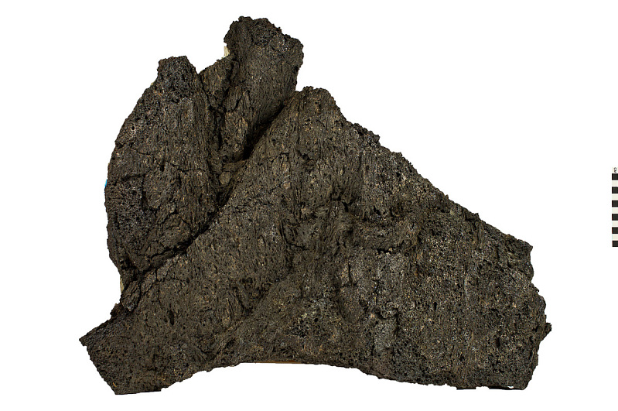

Notes Overview – HS-ESS1-6
Iron-Nickel Meteorite from the Canyon Diablo fall is at Yale University
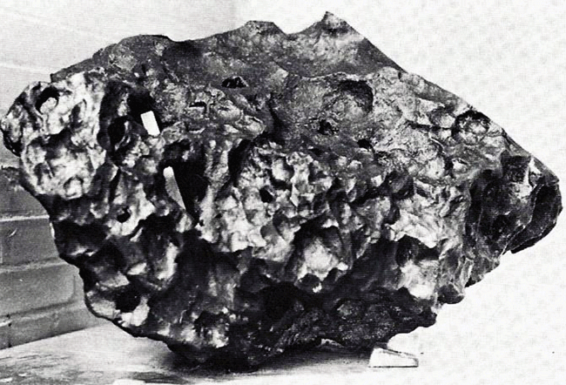

Stony Meteorite
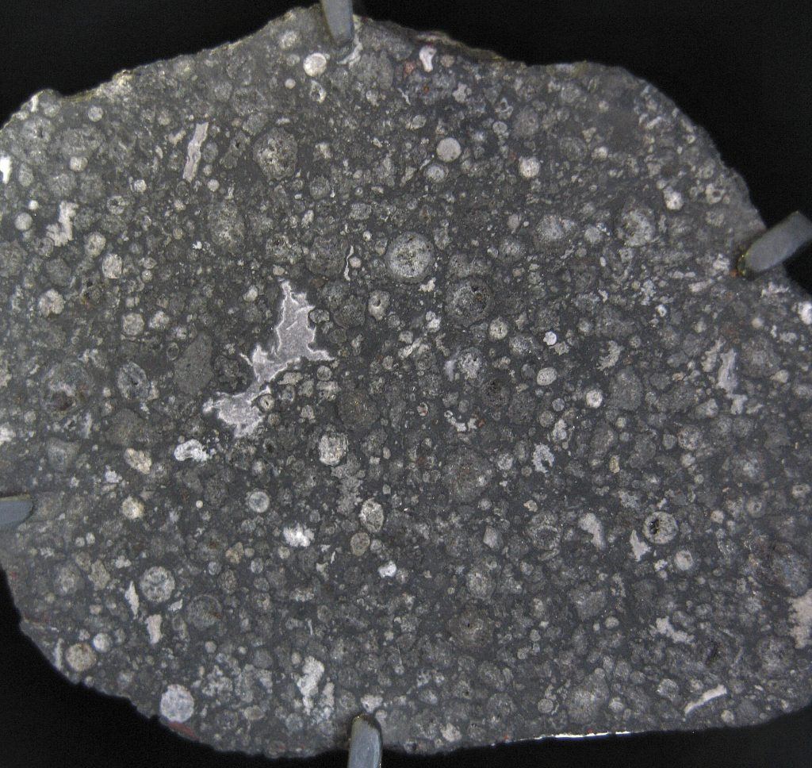
Notes Overview – HS-ESS1-6

Images for ACTIVITY 6 – IMPACT CRATERING ANALYSIS

Martian Crater Density Map
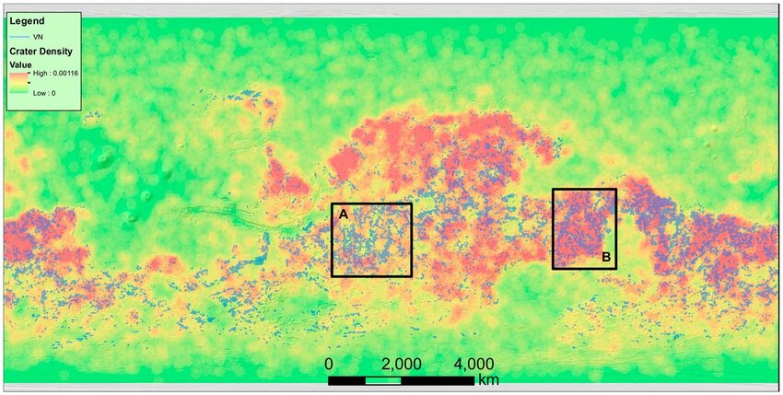

Lunar Crater Density Map
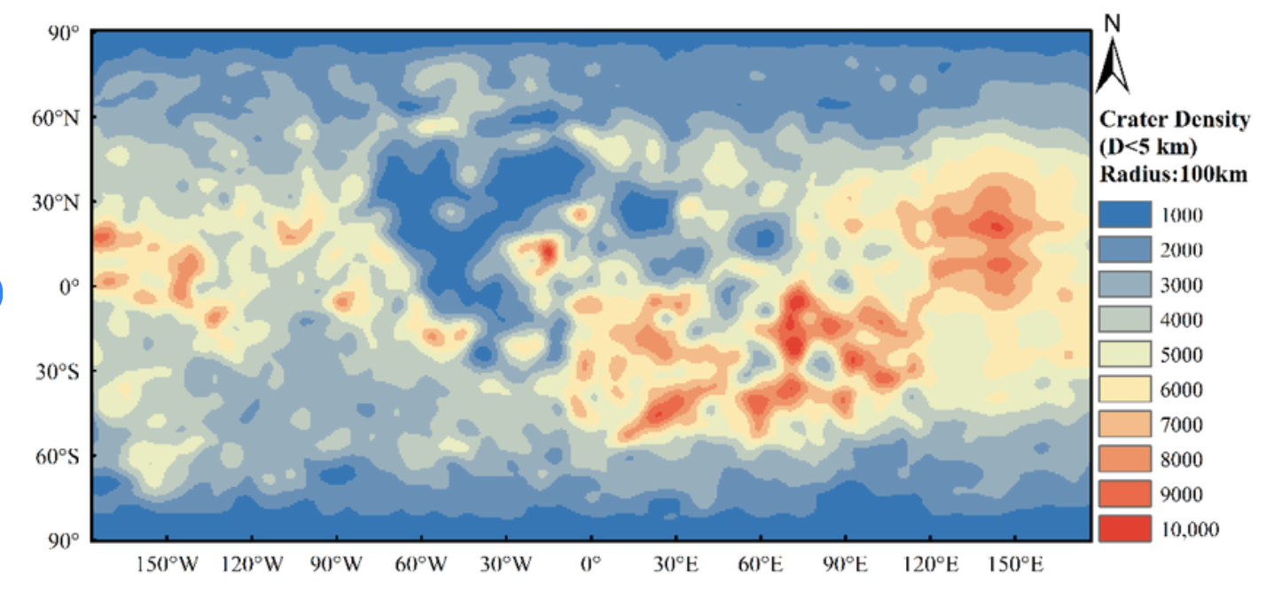
Notes Overview – HS-ESS1-6
Crater Formation
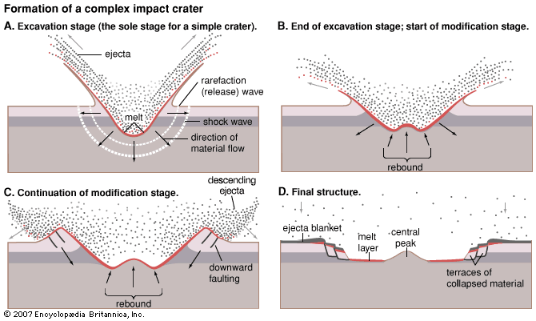

Barringer Crater
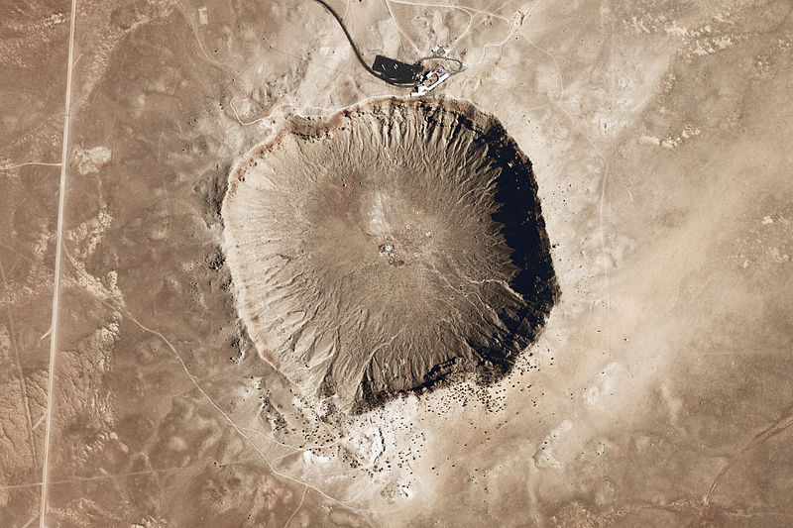
Notes Overview – HS-ESS1-6

Gale Crater
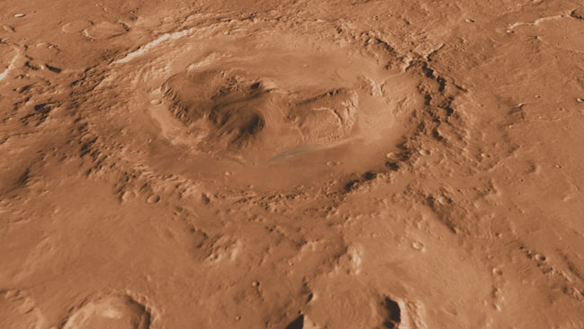
Name: Geologic History
Date: Period: Earth and Space Science
Activity – Comparison of Earth's Materials with Meteorites

ACTIVITY 1 – EXAMINATION OF SAMPLES
Examine the provided samples (or images) of Earth rocks and various types of meteorites. List three key similarities and three key differences between Earth rocks and meteorites.
SIMILARITIES:

DIFFERENCES:

ACTIVITY 2 – CHEMICAL COMPOSITION COMPARISON
The data table below compares the chemical compositions and isotopic ratios of Earth rocks and meteorites. Identify any significant patterns or anomalies.
Sample Type | Chemical Composition | Isotopic Ratios
Earth Rock 1 | SiO₂: 72%, Al₂O₃: 15%, FeO: 3% | ⁸⁷Sr/⁸⁶Sr: 0.710, ¹⁴³Nd/¹⁴⁴Nd: 0.512
Earth Rock 2 | SiO₂: 50%, Fe₂O₃: 10%, MgO: 8% | ⁸⁷Sr/⁸⁶Sr: 0.703, ¹⁴³Nd/¹⁴⁴Nd: 0.513
Meteorite 1 | Fe: 90%, Ni: 8%, Co: 1% | ⁸⁷Sr/⁸⁶Sr: 0.699, ¹⁴³Nd/¹⁴⁴Nd: 0.511
Meteorite 2 | SiO₂: 35%, MgO: 25%, FeO: 20% | ⁸⁷Sr/⁸⁶Sr: 0.702, ¹⁴³Nd/¹⁴⁴Nd: 0.510

Patterns:
Anomalies:

Activity – Comparison of Earth's Materials with Meteorites
ACTIVITY 3 – CONSTRUCTING AN ACCOUNT OF EARTH'S FORMATION
Using the evidence from ancient Earth materials and meteorites, construct a brief account of Earth's formation and early history. Include at least two pieces of scientific evidence in your explanation.

ACTIVITY 4 – RADIOMETRIC DATING EVIDENCE
Describe how radiometric dating of rocks can be used to construct an account of the formation or early history of Earth or other objects in the solar system. Provide an example with specific isotopes used.

ACTIVITY 5 – EVALUATION OF EVIDENCE
Describe or identify the evidence from ancient Earth materials, meteorites, or other planetary surfaces that support or refute the given explanation below of Earth’s formation and/or early history. Use evidence from radiometric dating to support your answer.
Explanation to support or refute: Earth formed primarily from the accumulation of meteorites with high nickel content.

Activity – Comparison of Earth's Materials with Meteorites
ACTIVITY 6 – IMPACT CRATERING ANALYSIS
Identify the evidence from impact cratering that supports or refutes a given explanation of Earth’s or another planetary surface formation or early history. Discuss the significance of crater density and distribution.

Activity – Comparison of Earth's Materials with Meteorites
KEY – Example responses include:
- Similarities:
  - Both Earth rocks and meteorites contain silicate minerals.
  - Both have varied textures and mineral compositions.
  - Both can show evidence of past geological processes, such as melting or differentiation.
Differences:
  - Earth rocks typically have a higher concentration of silica (SiO₂), while meteorites often have higher metal content (e.g., iron and nickel).
  - Meteorites may show fusion crusts from atmospheric entry, which Earth rocks do not.
  - Meteorites can contain chondrules, small spherical inclusions, which are not found in Earth rocks.
- Patterns: Earth rocks tend to have higher silica content compared to meteorites. Meteorites show higher metal content, particularly in iron and nickel.
Anomalies: The isotopic ratios for meteorites are generally lower compared to Earth rocks, suggesting differences in their formation history.
- Earth formed approximately 4.6 billion years ago from the solar nebula. Accretion of dust and gas led to the formation of planetesimals, which eventually coalesced to form Earth. Evidence supporting this includes:
The presence of iron-nickel meteorites suggests they originated from differentiated bodies, indicating that early planetesimals underwent melting and differentiation.
Radiometric dating of Earth rocks and meteorites provides consistent ages, around 4.5 billion years, supporting a common timeframe for the formation of solar system objects.
- Radiometric dating measures the decay of radioactive isotopes to determine the age of rocks. For example, Uranium-238 decays to Lead-206 with a half-life of 4.47 billion years. By measuring the ratio of Uranium to Lead in a rock sample, scientists can calculate its age. This technique has been used to date the oldest Earth rocks and meteorites, providing evidence for the age of the Earth and the early solar system.
- Evidence supporting this explanation includes the high nickel content found in many iron meteorites, which suggests that planetesimals contributing to Earth's formation had undergone differentiation. Radiometric dating of these meteorites provides ages consistent with Earth's formation timeline.
However, Earth rocks, particularly crustal rocks, show higher silica content and different isotopic ratios, indicating that not all material contributing to Earth's formation was metal-rich. This suggests a more complex accretion process involving a variety of materials.
- Impact cratering provides evidence of early solar system processes. The density and distribution of craters on the Moon, for example, indicate a period of heavy bombardment around 4 billion years ago. This supports the idea that Earth and other planetary bodies underwent significant impacts during their formation and early history. High crater density on the Moon and other planetary surfaces suggests that these bodies have preserved ancient impact records, which can be used to infer the timing and intensity of early solar system events. On Earth, erosion and tectonic activity have erased many ancient craters, but studies of lunar craters provide indirect evidence of Earth's early impact history.

Name: Geologic History
Date: Period: Earth and Space Science
Notes Overview – HS-ESS1-6
Explore how scientists use evidence from ancient Earth materials, meteorites, and planetary surfaces to construct an account of Earth’s formation and early history.

Core Objectives:
- Understand Radiometric Dating Techniques: Learn how scientists determine the age of rocks and meteorites.
- Compare Earth's Materials with Meteorites: Analyze the similarities and differences to understand their origins.
- Analyze Planetary Surfaces: Study how the features of planetary surfaces help us reconstruct the early solar system.

The Role of Planetary Surfaces in Understanding the Early Solar System

OVERVIEW
The surfaces of planets and moons hold a record of the processes that shaped the early solar system.

KEY FEATURES
- Impact Cratering: The number and distribution of craters can indicate the age of a planetary surface.
- Volcanism: Indicates geological activity and provides clues about the interior composition and thermal history.
- Tectonics: Surface features like rifts and faults reveal the mechanical forces acting on a planetary body.

ANALYSIS ACTIVITY
- Mapping Crater Distribution: Students will use diagrams and photos of planetary surfaces (like the Moon and Mars) to map and date surfaces based on crater density.
- Comparative Study: Analyze the differences between Earth's surface and those of other planetary bodies to infer their geological histories.

Activity – The Role of Planetary Surfaces in Understanding the Early Solar System
SCENARIO 1 – MAPPING CRATER DISTRIBUTION
The data chart below provides a comparative overview of the crater density and geological features of the Moon's surface and Mars's surface.
Feature | Moon | Mars
Crater Density | High in older highlands, lower in younger maria | High in southern highlands, lower in northern plains
Surface Age | 4.5 billion years (highlands), 3-3.5 billion years (maria) | 4.2-4.5 billion years (highlands), younger plains
Volcanic Activity | Inactive for billions of years, ancient mare basalt flows | Extensive past activity, Olympus Mons and Tharsis region
Tectonic Activity | None currently, evidence of past tectonics in rilles | Past tectonic activity, evidence in Valles Marineris
Erosion Processes | Minimal due to lack of atmosphere and water | Significant, wind erosion, ancient water flow evidence

Earth’s Moon
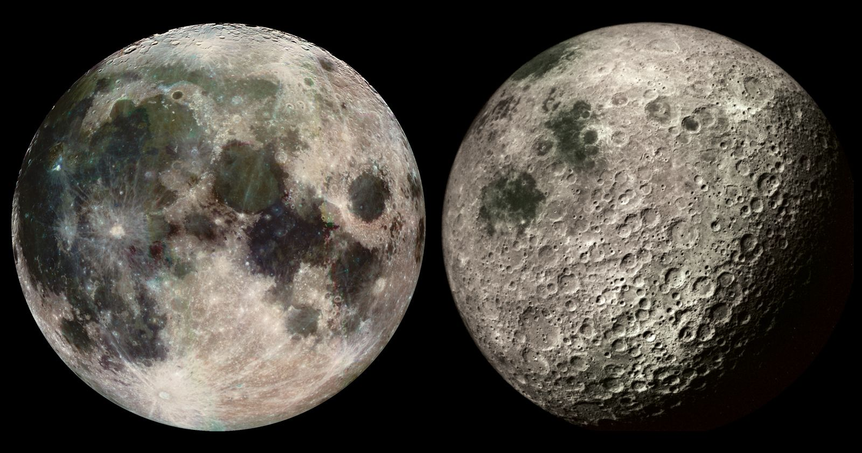

Activity – The Role of Planetary Surfaces in Understanding the Early Solar System
Earth’s Moon – some craters labeled
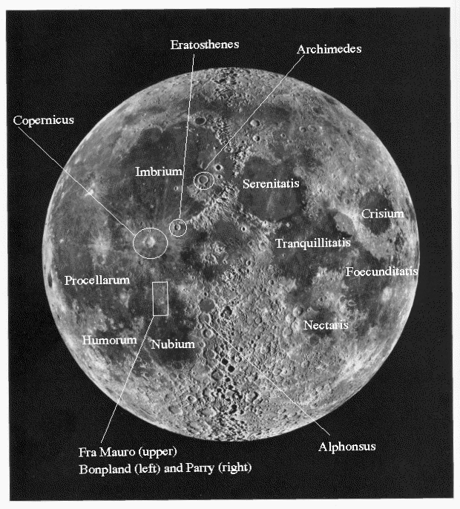
Topographic Map of Mars’s surface
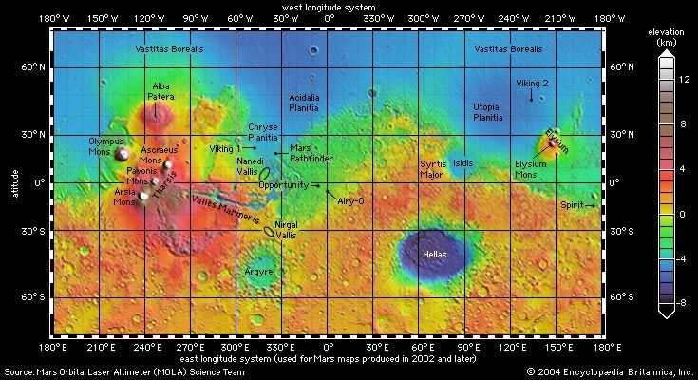
Activity – The Role of Planetary Surfaces in Understanding the Early Solar System

Instructions: Use the diagrams provided of the Moon’s surface and of Mars’s surface to answer the following questions.
- Based on the density of craters in different areas of the Moon's surface, which region would you identify as the oldest? Explain your reasoning.

- Compare the crater density of the Moon's surface to that of Mars's surface. What does the difference in crater density tell you about the geological history of these two planetary bodies?

Activity – The Role of Planetary Surfaces in Understanding the Early Solar System
SCENARIO 2 – COMPARATIVE STUDY
Himalayas
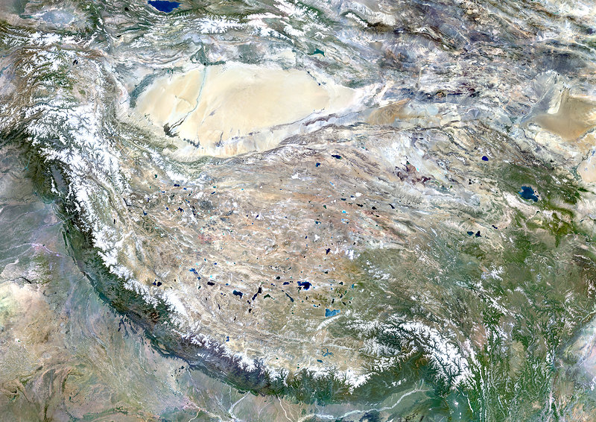
Satellite image showing the high mountain ranges of the Himalayas on Earth formed by tectonic collision.

Mid-Atlantic Ridge
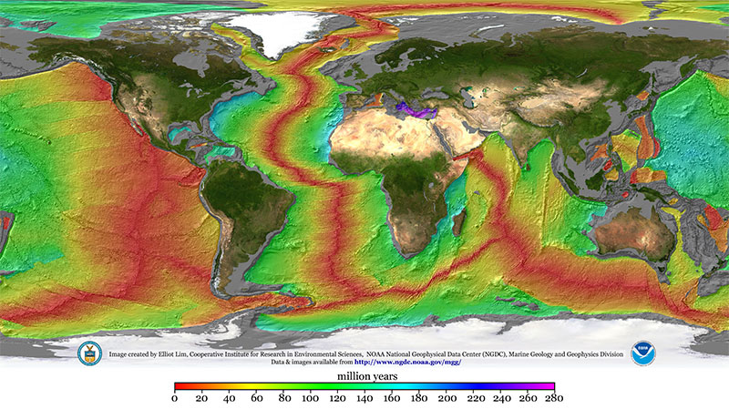
Underwater image showing the ridge where the Eurasian and North American Plates are diverging.
Activity – The Role of Planetary Surfaces in Understanding the Early Solar System

Grand Canyon
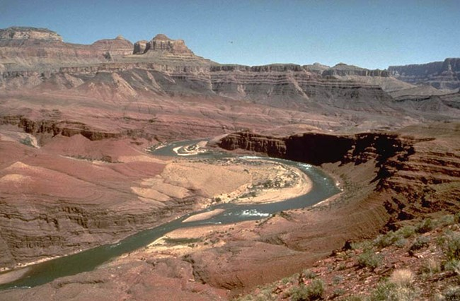
Images displaying the erosion and sedimentation processes that have shaped the Grand Canyon over millions of years.

Activity – The Role of Planetary Surfaces in Understanding the Early Solar System

Aeolis Dorsa Region
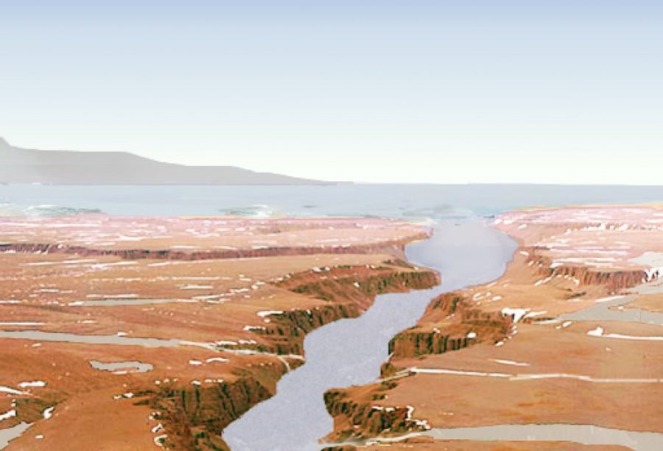
High-resolution images from the HiRISE camera aboard the Mars Reconnaissance Orbiter show detailed features of ancient riverbeds and delta formations in Aeolis Dorsa. These images reveal the topography and patterns of inverted channels, indicating significant past water flow into a large basin, possibly an ancient ocean.

Volcanic Regions (Olympus Mons)
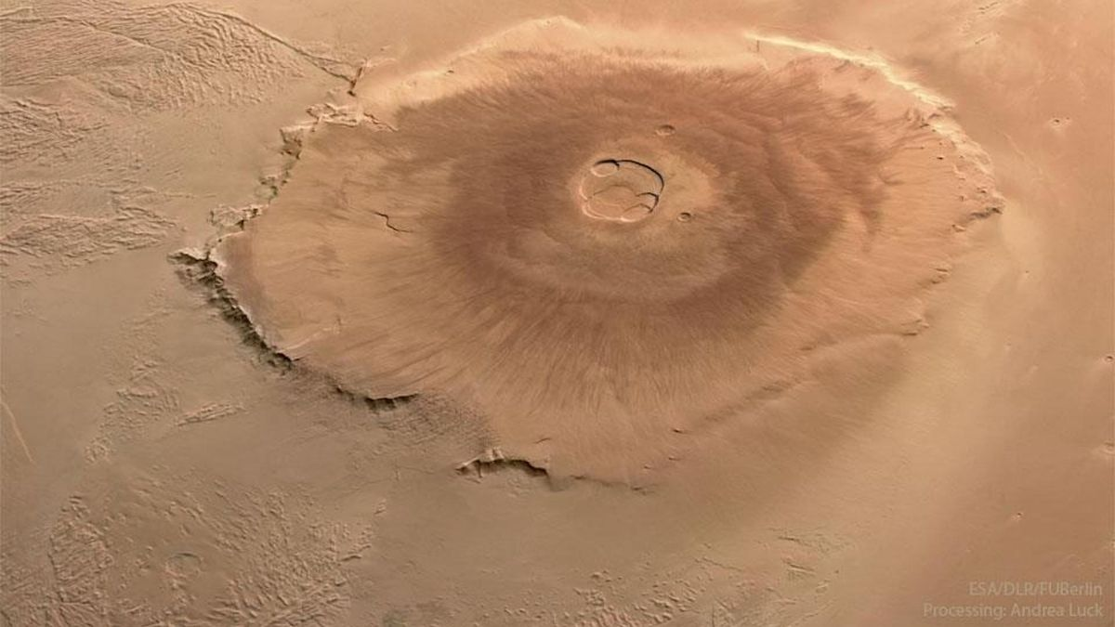
The largest volcano in the solar system, Olympus Mons stands about 22 km high and spans 600 km in diameter. Images from the Mars Express probe illustrate the extensive lava flows and landslides around the volcano's base. These flows interacted with ice and water, leading to significant geological changes like the formation of Lycus Sulci, a region characterized by massive landslides extending over 1000 km from the volcano.

Activity – The Role of Planetary Surfaces in Understanding the Early Solar System
Data Chart on Plate Movements, Erosion Rates, and Geological Processes
Process | Measurement/ Rate | Description
Plate Movement (Himalayas) | 5 cm/year (Indian Plate) | The rate at which the Indian Plate is moving northward
Plate Movement (Mid-Atlantic Ridge) | 2.5 cm/year (Eurasian Plate) | The rate of seafloor spreading at the Mid-Atlantic Ridge
Erosion Rate (Grand Canyon) | 0.07 mm/year | Average rate of erosion contributing to canyon formation
Volcanic Activity (Hawaii) | Continuous | Ongoing volcanic activity contributing to island growth
Sedimentation Rate (Mississippi Delta) | 2-5 cm/year | Rate of sediment deposition in the delta
Volcanic Activity (Olympus Mons) | Last major activity ~100 million years ago | Evidence of significant lava flows and landslides from volcanic activity
Sedimentation Rate (Mars) | Varies by location | Sedimentary deposits in regions like Aeolis Dorsa indicate past water flow
Instructions: Analyze the provided images and data of Earth’s surface and the surface of Mars from above to answer the following questions.

- List three major differences between Earth’s surface and Mars’s surface that can be observed from the images and data provided. How do these differences help infer the geological histories of Earth and Mars?

- Using the evidence from the images and data, construct an account of the early geological history of Mars. How does this compare to Earth's early geological history?

Activity – The Role of Planetary Surfaces in Understanding the Early Solar System

SCENARIO 3 – RADIOMETRIC DATING AND EVIDENCE ANALYSIS
The data chart below show the radiometric dating of rocks from Earth and meteorites, showing sample types, locations, ages, and dating methods. This chart can be used to illustrate the various ages of materials in the solar system and the methods used to determine these ages.
Sample Type | Location | Age (billion years) | Dating Method
Zircon Crystals | Australia | 4.4 | Uranium-Lead
Basalt Rock | Hawaii | 3.5 | Potassium-Argon
Lunar Rock | Moon | 4.0 | Uranium-Lead
Martian Meteorite | Mars | 4.4 | Rubidium-Strontium
Chondrite Meteorite | Asteroid Belt | 4.56 | Uranium-Lead

Instructions: Examine the provided data on radiometric dating of rocks from Earth and meteorites.
- How can radiometric dating of ancient Earth materials provide evidence for the formation of Earth? Provide a specific example from the data.

- A meteorite sample has been radiometrically dated to be 4.56 billion years old. What does this age suggest about the time of formation of objects in the solar system? Use scientific reasoning to support your answer.

Activity – The Role of Planetary Surfaces in Understanding the Early Solar System

ASSESSMENT RUBRIC:
- Questions 1 and 2: Understanding of crater density and its relation to surface age, ability to compare and analyze different planetary surfaces.
- Questions 3 and 4: Identification of geological features, comparative analysis, construction of geological history.
- Questions 5 and 6: Application of radiometric dating knowledge, evidence-based reasoning to support conclusions about Earth's and solar system's formation.

Activity – The Role of Planetary Surfaces in Understanding the Early Solar System
KEY – Example responses include:
- The region with the highest density of craters would be identified as the oldest. This is because older surfaces have had more time to accumulate impacts from meteoroids. Therefore, the area on the diagram with the most craters is the oldest.
- The Moon generally has a higher crater density compared to Mars. This suggests that the Moon's surface is older and has been geologically inactive for a longer period. In contrast, Mars shows signs of geological activity, such as volcanoes and erosion, which have resurfaced parts of the planet, leading to fewer visible craters.
- Earth has active plate tectonics, leading to mountain ranges and deep ocean trenches, while Mars does not show evidence of current tectonic activity.
Earth’s surface has abundant liquid water, evidenced by rivers, lakes, and oceans, whereas Mars shows signs of past water activity but currently has no stable liquid water.
Earth’s atmosphere is thick and supports life, resulting in weathering and erosion processes, whereas Mars has a thin atmosphere, leading to less weathering and erosion.
These differences indicate that Earth has a dynamic, active geological history, influenced by water and tectonics, while Mars has a more static geological history, primarily shaped by impacts and past volcanic activity.
- Mars's early geological history likely involved significant volcanic activity, which created large volcanoes like Olympus Mons. The presence of dried-up riverbeds and minerals that form in water indicates that liquid water was once present. Compared to Earth, Mars cooled faster, leading to the cessation of volcanic and tectonic activity earlier than on Earth. Earth's early history involved active volcanism, the formation of a thick atmosphere, and the development of plate tectonics, all of which contributed to its current geological diversity.
- Radiometric dating of ancient Earth materials, such as zircon crystals, can provide ages of up to 4.4 billion years. This evidence suggests that Earth formed soon after the solar system began to coalesce. For example, a zircon crystal from Australia dated at 4.4 billion years indicates that Earth's crust started forming very early in its history.
- A meteorite sample dated to 4.56 billion years old suggests that it formed very soon after the solar system began to form. This age aligns with the estimated age of the solar system, indicating that the meteorites are some of the oldest materials available and provide a timeline for the formation of the solar system. This evidence supports the idea that the planets, including Earth, began forming around this time.

Name: Geologic History
Date: Period: Earth and Space Science
Activity – Integrating the Evidence

PART 1 – UNDERSTANDING RADIOMETRIC DATING
- Explain the concept of radiometric dating – Radiometric dating is a method used to determine the age of rocks and other materials based on the decay rate of radioactive isotopes. Describe how this method works and why it is useful in studying Earth's history.

PART 2 – DATA ANALYSIS
- Using the provided data from radiometric dating results, mark the key events on the cash register tape to create a timeline of Earth's formation and early history.
Sample Type | Age (in billion years) | Key Information
Earth Rock | 4.0 | Contains early minerals
Moon Rock | 4.4 | Similar composition to Earth’s crust
Meteorite | 4.6 | Contains primitive solar system material
Steps:
  - Measure and cut a length of cash register tape to represent 4.6 billion years. (e.g., 1 inch = 100 million years)
  - Mark the start of the timeline at 4.6 billion years ago on one end of the tape.
  - Using a ruler, mark the following points on the tape:
    - 4.6 billion years ago (Meteorite)
    - 4.4 billion years ago (Moon Rock)
    - 4.0 billion years ago (Earth Rock)
  - Label each mark with the corresponding event and key information.

Activity – Integrating the Evidence
PART 3 – CONSTRUCTING AN ACCOUNT OF EARTH’S FORMATION
- Construct an account of Earth's formation and early history using scientific reasoning and evidence from the provided samples. Include the age and composition of Earth rocks, moon rocks, and meteorites in your explanation.

PART 4 – EVALUATING EXPLANATIONS
- Describe or identify the evidence that supports or refutes a given explanation of Earth’s formation and/or early history.
Explanation A: Earth's formation was a result of gradual accumulation of space debris.
Explanation B: Earth formed rapidly from a proto-planetary disk.
- Supporting Evidence for Explanation A:
- Refuting Evidence for Explanation A:
- Supporting Evidence for Explanation B:
- Refuting Evidence for Explanation B:

Activity – Integrating the Evidence
PART 5 – IDENTIFYING EVIDENCE
- Identify the evidence (radiometric dating, impact cratering) that supports or refutes a given explanation of Earth's or another planetary surface formation or early history.
Explanation C: The moon formed from debris resulting from a collision between Earth and another planetary body.
- Supporting Evidence:
- Refuting Evidence:

PART 6 – CRITICAL THINKING AND APPLICATION
- Based on the timeline and evidence, discuss the significance of meteorites in understanding the early solar system. Why are meteorites crucial for constructing an account of the early solar system? What can they tell us that Earth and moon rocks cannot?

PART 7 – REFLECTION
- Reflect on the importance of radiometric dating in studying planetary formation. How has radiometric dating advanced our understanding of Earth's formation and early history? Discuss its impact on the field of Earth and Space Science.

Activity – Integrating the Evidence
KEY – Example responses include:
- Radiometric dating is a method used to determine the age of rocks and other materials by measuring the decay rate of radioactive isotopes within them. This method works because isotopes decay at predictable rates, allowing scientists to calculate the time elapsed since the rock or material formed. It is useful in studying Earth's history because it provides precise ages for geological events and formations.
- 4.6 billion years ago (Meteorite): Mark this at the start of the tape.
4.4 billion years ago (Moon Rock): Measure 2 inches from the start (if 1 inch = 100 million years) and mark it.
4.0 billion years ago (Earth Rock): Measure 6 inches from the start and mark it.
- Earth formed about 4.6 billion years ago from the accumulation of space debris in the early solar system. Meteorites, which date back to this time, provide evidence of the primitive materials that formed the solar system. Around 4.4 billion years ago, the moon formed, likely from debris resulting from a collision between Earth and another planetary body. By 4.0 billion years ago, Earth's crust had begun to solidify, as evidenced by ancient Earth rocks containing early minerals.
- Explanation A: Earth's formation was a result of gradual accumulation of space debris.
Supporting Evidence: The presence of ancient meteorites that date back to 4.6 billion years ago, containing primitive solar system material.
Refuting Evidence: The formation of the moon suggests a significant impact event, which might not align with gradual accumulation alone.
Explanation B: Earth formed rapidly from a proto-planetary disk.
Supporting Evidence: The rapid formation of the moon from a collision event supports the idea of a dynamic, fast-forming early solar system.
Refuting Evidence: The gradual accumulation of meteorites and debris over time suggests a more prolonged process.
- Explanation C: The moon formed from debris resulting from a collision between Earth and another planetary body.
Supporting Evidence: Similar composition of moon rocks and Earth's crust, indicating a shared origin.
Refuting Evidence: If additional evidence from radiometric dating of lunar materials showed significant compositional differences from Earth, it could refute this explanation.
- Meteorites are crucial for constructing an account of the early solar system because they contain primitive materials that have not been altered by geological processes. They provide a snapshot of the conditions and materials present during the formation of the solar system, offering insights that Earth and moon rocks, which have undergone significant changes, cannot provide.
- Radiometric dating has advanced our understanding of Earth's formation and early history by providing precise ages for rocks and geological events. It has allowed scientists to construct detailed timelines of Earth's development, understand the timing of major events like the formation of the moon, and gain insights into the processes that shaped the solar system. This method has significantly impacted the field of Earth and Space Science by providing a reliable tool for dating and studying ancient materials.

Name: Geologic History
Date: Period: Earth and Space Science
Worksheet – Important Radioactive Elements Used for Radiometric Dating
- Which radioactive element is commonly used for dating ancient organic materials?

  - Uranium-238
  - Potassium-40
  - Carbon-14
  - Thorium-232

- What is the half-life of Carbon-14?

  - 5,730 years
  - 1.3 billion years
  - 4.5 billion years
  - 75,000 years

- Which element decays into Argon-40, making it useful for dating rocks?

  - Uranium-238
  - Thorium-232
  - Potassium-40
  - Rubidium-87

- What is the half-life of Uranium-238?

  - 1.3 billion years
  - 4.5 billion years
  - 5,730 years
  - 75,000 years

- Which radioactive element is used for dating very old rocks due to its long half-life of about 48.8 billion years?

  - Rubidium-87
  - Potassium-40
  - Uranium-238
  - Thorium-232

- Thorium-232 decays into which stable element?

  - Argon-40
  - Lead-208
  - Strontium-87
  - Nitrogen-14

- The decay of Uranium-235 is used to date rocks and minerals. What stable element does it decay into?

  - Lead-207
  - Argon-40
  - Lead-206
  - Strontium-87

- What is the daughter product of the radioactive decay of Rubidium-87?

  - Lead-207
  - Strontium-87
  - Argon-40
  - Lead-206

- Which radioactive element has a half-life of approximately 1.3 billion years?

  - Uranium-235
  - Potassium-40
  - Rubidium-87
  - Thorium-232

- Radiometric dating is most effective for which type of rocks?

  - sedimentary rocks
  - igneous rocks
  - metamorphic rocks
  - fossil
Worksheet – Important Radioactive Elements Used for Radiometric Dating

Answer Key:
- C. Carbon-14
- A. 5,730 years
- C. Potassium-40
- B. 4.5 billion years
- A. Rubidium-87
- B. Lead-208
- A. Lead-207
- B. Strontium-87
- B. Potassium-40
- B. igneous rocks

Name: Geologic History
Date: Period: Earth and Space Science
Worksheet – ESRT Review – Geologic History of New York State
- During which geologic period did the Taconic Orogeny occur?

  - Cambrian
  - Ordovician
  - Silurian
  - Devonian

- What type of rock is predominantly found in the Adirondack Mountains?

  - Sedimentary
  - Igneous
  - Metamorphic
  - Volcanic

- The Hudson Highlands were primarily formed during which geologic event?

  - Taconic Orogeny
  - Acadian Orogeny
  - Alleghenian Orogeny
  - Grenville Orogeny

- Which period is known for the formation of extensive coal swamps in New York State?

  - Mississippian
  - Pennsylvanian
  - Permian
  - Triassic

- The Catskill Delta formed during which geologic period?

  - Devonian
  - Carboniferous
  - Silurian
  - Ordovician

- The Iapetus Ocean closed during which geologic event?

  - Taconic Orogeny
  - Acadian Orogeny
  - Alleghenian Orogeny
  - Grenville Orogeny

- Which type of rock is commonly found in the Finger Lakes region?

  - Limestone
  - Sandstone
  - Shale
  - Granite

- The Niagara Escarpment primarily consists of which type of rock?

  - Limestone
  - Sandstone
  - Shale
  - Dolostone

- During which period did the Pleistocene Epoch occur?

  - Tertiary
  - Quaternary
  - Cretaceous
  - Jurassic

- Which era is known for the presence of dinosaurs in New York State?

  - Paleozoic
  - Mesozoic
  - Cenozoic
  - Precambrian

Worksheet – ESRT Review – Geologic History of New York State
- What is the primary rock type of the Palisades Sill?

  - Granite
  - Basalt
  - Limestone
  - Shale

- The Great Appalachian Valley was formed primarily during which orogeny?

  - Taconic Orogeny
  - Acadian Orogeny
  - Alleghenian Orogeny
  - Grenville Orogeny

- Which period saw the most recent glaciation in New York State?

  - Pliocene
  - Pleistocene
  - Miocene
  - Holocene

- The Helderberg Escarpment is mainly composed of which type of rock?

  - Basalt
  - Shale
  - Limestone
  - Sandstone

- Which geologic period is known for the extensive deposition of evaporites in New York State?

  - Cambrian
  - Silurian
  - Devonian
  - Mississippian

- The Taconic Mountains were uplifted primarily during which period?

  - Cambrian
  - Ordovician
  - Silurian
  - Devonian

- What is the primary age of the rocks in the Hudson-Mohawk Lowlands?

  - Precambrian
  - Paleozoic
  - Mesozoic
  - Cenozoic

- Which geologic period is known for the widespread formation of limestone in New York State?

  - Cambrian
  - Ordovician
  - Silurian
  - Devonian

- The Alleghenian Orogeny mainly affected which part of New York State?

  - Western New York
  - Northern New York
  - Southern New York
  - Eastern New York

- During which period did the Acadian Orogeny occur?

  - Cambrian
  - Ordovician
  - Silurian
  - Devonian

Worksheet – Geologic History of New York State

Answer Key:
- B. Ordovician
- C. Metamorphic
- D. Grenville Orogeny
- B. Pennsylvanian
- A. Devonian
- B. Acadian Orogeny
- C. Shale
- D. Dolostone
- B. Quaternary
- B. Mesozoic
- B. Basalt
- C. Alleghenian Orogeny
- B. Pleistocene
- C. Limestone
- B. Silurian
- B. Ordovician
- B. Paleozoic
- C. Silurian
- C. Southern New York
- D. Devonian

Name: Geologic History
Date: Period: Earth and Space Science
Quiz – Formation and Early History of Earth and the Solar System
Directions (1–10): For each statement or question, choose the word or expression that, of those given, best
completes the statement or answers the question. Some questions may require the use of the 2024 Edition Reference Tables for Earth and Space Science. Record your answers on your separate answer sheet.

- Which radioactive element is commonly used for dating ancient rocks and meteorites?

  - Uranium-238
  - Carbon-14
  - Potassium-40
  - Thorium-232

- The half-life of Uranium-238 is approximately:

  - 5,730 years
  - 1.3 billion years
  - 4.5 billion years
  - 48.8 billion years

- What type of evidence do scientists use to determine the age of Earth’s oldest rocks?

  - Fossil records
  - Radiometric dating
  - Ice core samples
  - Sediment layers

- Which of the following do meteorites provide information about?
  - Earth’s atmospheric conditions
  - The early solar system
  - Volcanic activity on Earth
  - Earth’s magnetic field

- The decay of Potassium-40 into Argon-40 is used to date:

  - Organic materials
  - Sedimentary rocks
  - Igneous rocks
  - Glacial deposits

- Which of the following best describes the process of radiometric dating?
  - Measuring the depth of rock layers
  - Calculating the relative proportions of radioactive isotopes and their decay products
  - Observing the fossil content within rocks
  - Comparing rock layers from different geographic locations

- Why is the presence of zircon crystals in ancient rocks is significant?
  - They are found only on Earth.
  - They can survive geological processes and provide information about early Earth.
  - They indicate recent volcanic activity.
  - They are used to date organic materials.

Quiz – Formation and Early History of Earth and the Solar System
- Which geologic era is known as the "age of the Earth’s formation"?
  - Paleozoic
  - Mesozoic
  - Cenozoic
  - Precambrian

- The evidence of heavy bombardment on planetary surfaces, such as the Moon, suggests:
  - Continuous volcanic activity
  - A calm and stable early solar system
  - Frequent asteroid impacts during the early history of the solar system
  - Recent geological activity

- Which radioactive isotope is often used to date the age of the Earth?
  - Carbon-14
  - Uranium-238
  - Potassium-40
  - Thorium-232

Directions (11–15): Record your answers in the spaces provided in your answer booklet. Some questions may
require the use of the 2024 Edition Reference Tables for Earth and Space Science.

- Explain how radiometric dating of meteorites contributes to our understanding of the age of the solar system.

- Describe the significance of finding similar rock types and ages on both Earth and the Moon. What does this suggest about the history of these two bodies?

- Using the concept of half-life, explain how scientists determine the absolute age of a rock sample.

- Discuss how the study of impact craters on other planetary surfaces, like Mars or the Moon, helps scientists infer the history of Earth’s formation and early solar system events.

- Identify one piece of evidence from ancient Earth materials that supports the theory of Earth’s formation and describe its significance.
Name: Geologic History
Date: Period: Earth and Space Science
Answer Booklet – Formation and Early History of Earth and the Solar System



Answer Booklet – Formation and Early History of Earth and the Solar System

Quiz – Formation and Early History of Earth and the Solar System

Answer Key:
- A. Uranium-238
- C. 4.5 billion years
- B. Radiometric dating
- B. The early solar system
- C. Igneous rocks
- B. Calculating the relative proportions of radioactive isotopes and their decay products
- B. They can survive geological processes and provide information about early Earth
- D. Precambrian
- C. Frequent asteroid impacts during the early history of the solar system
- B. Uranium-238

Example responses include:

11. Radiometric dating of meteorites involves measuring the ratios of parent to daughter isotopes in the meteorites. This method has shown that the oldest meteorites are about 4.56 billion years old, which provides a minimum age for the formation of the solar system.

12. Finding similar rock types and ages on both Earth and the Moon suggests that they share a common history, potentially indicating that they formed from the same material or that they experienced similar processes early in the solar system’s history.

13. Scientists determine the absolute age of a rock sample by measuring the proportion of radioactive parent isotopes to their stable daughter products. By knowing the half-life of the parent isotope, they can calculate the time it has taken for a certain amount of the parent isotope to decay, thus determining the age of the rock.

14. Impact craters on planetary surfaces provide evidence of past collisions with asteroids or comets. By studying these craters, scientists can infer the frequency and intensity of impacts during the early history of the solar system, which helps them understand similar processes on Earth.

15. One piece of evidence from ancient Earth materials that supports the theory of Earth’s formation is the presence of ancient zircon crystals. These crystals can be over 4 billion years old and provide information about the conditions of early Earth, suggesting a relatively rapid cooling and crust formation after the planet’s initial formation.

